Assignment for Module 9
The assignment for Module 9 provides practice applying the ERD notation to narrative problem descriptions and detecting/resolving design errors. I encourage you to use the ER Assistant or Visual Paradigm to complete the problems in module 9. Module 7 contains software demonstrations for both the ER Assistant and Visual Paradigm.
1. Requirements for Data Modeling Problems
- For the following problem, define an ERD for the initial requirements and then revise the ERD for the new requirements. Your solution should have an initial ERD, a revised ERD, and a list of design decisions for each ERD. In performing your analysis, you may want to follow the approach presented in module 9.
Design a database for managing the task assignments on a work order. A work order records the set of tasks requested by a customer at a specified location.
- A customer has a unique customer identifier, a name, a billing address (street, city, state, and zip), and a collection of submitted work orders.
- A work order has a unique work order number, a creation date, a date required, a completion date, a customer, an optional supervising employee, a work address (street, city, state, zip), and a set of tasks.
- Each task has a unique task identifier, a task name, an hourly rate, and estimated hours. Tasks are standardized across work orders so that the same task can be performed on many work orders.
- Each task on a work order has a status (not started, in progress, or completed), actual hours, and a completion date. The completion date is not entered until the status changes to complete.
After reviewing your initial design, the company decides to revise the requirements. Make a separate ERD to show your refinements. Refine your original ERD to support the following new requirements:
- The company wants to maintain a list of materials. The data about materials include a unique material identifier, a name, and an estimated cost. A material can appear on multiple work orders.
- Each work order uses a collection of materials. A material used on a work order includes the estimated quantity of the material and the actual quantity of the material used.
- The estimated number of hours for a task . Each task of a work order includes an estimated number of hours.
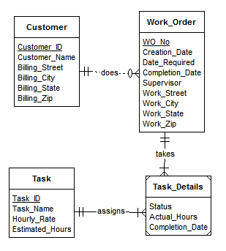
INITIAL DESIGN
Customer, Work__Order, Task_Details, Task are the Entitiy types where Customer to Work_Order, Work_Order to Task_Details and Task to Task_Details has 1-M relation.
Customer does work through work order.
Work order takes the task details.
Task details assigns Task.
Minimum cardinality details are not given so additional requirment collection is neccessary.
Trasformations :
Entity types Maerial and Material Used are added as per requirements.
1-M relationship is maintained between Work Order to Material Used and Material to Material Used Entity types.
Estimated Hours from task entity type is moved to Task Details entity type.
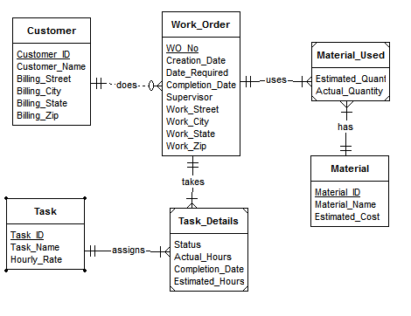
REVISED DESIGN
After the transformations the Entity Types present are Customer, Work Order, Material Used, Material, Task Details and Task.
Attribute Estimated Hours is added in Task Details since it depends on the work order and task, not on the task alone
Materials are used by work order.
- For the Auto Dealership ERD shown in Figure 1, identify and resolve errors and note incompleteness in the specifications. Your solution should include a list of errors and a revised ERD. For each error, identify the type of error (diagram or design) and the specific error within each error type. Note that the ERD may have both diagram and design errors. Specifications for the ERD are presented in the following narrative.
Mountain High Quality Vehicles serves a metropolitan market with a medium size inventory of pre-owned cars and trucks. The vehicle inventory includes a variety of makes and models such as Acura, Chrysler, BMW, Cadillac, Ford, Chevrolet, Toyota, Honda, Mercedes-Benz, and more. A small staff manages the major functions of the business, purchasing, transporting, marketing, cleaning, maintaining, and selling the vehicles. They carefully inspect and certify the vehicles before they are available to the public for sale.
The dealership would like to develop an inventory management database to improve its tracking of vehicles, sales, and expenses. The dealership also would like to track information about its customers and car(s) sold to its customers.
- Vehicle Acquisitions: Periodically the owners attend auctions and purchase pre owned cars seeking reasonable prices and quality vehicles. They also purchase pre-owned vehicles from the wholesale market. The purchased vehicles are transported to the dealership and inspected for mechanical problems. Each vehicle is fixed and cleaned before being placed for sale.
- Vehicle Improvements: Apart from purchases, the dealership has additional expenses to prepare vehicles for market. The expenses typically involve transporting the purchased vehicle to the dealership, checking the vehicle for any potential problem, repairs and maintenance if necessary, marketing and cleaning.
- Sales Details: Customers purchase vehicles at the dealership. Each sale involves one customer even for married couples. Although customers can purchase more than one vehicle, each vehicle is recorded as a separate sale. When a sale is completed, the employee associated with the sale and payments are recorded. Typically, vehicles remain on the lot for a period of time before sales occur.
- Vehicle Details: The database tracks the unique vehicle identifier and vehicle identification number (VIN) to complete a sales transaction. The database also tracks vehicle characteristics such as make, model, year, mileage, exterior and interior colors, transmission type (automatic or manual), and number of cylinders (4 or 6).
- Customer Details: The database records the unique customer number, first and last names, address, city, state, postal code, primary phone number, and cellphone number.
- Expense Details: Each vehicle expense has a unique expense identifier, expense type, expense description, expense amount, expense paid date, account, and associated vehicle.
- Account Details: The database tracks account details such as a unique account identifier, account description, related expenses, and related payments.
- Payment Details: The database also tracks the vehicle sale (payment process). Each payment has a unique invoice number and payment method. The payment options are cash, credit card, or external line of credit as no financing is available at the dealership. Typically one payment is made per sale although multiple payments are sometimes made if a customer provides cash for part of the sale. If a customer is paying with a credit card, the payment includes the credit card number, expiration date, name on the credit card, and payment description. The employee that completed the sales transaction and vehicle should be recorded. The same employee works as sales associate and processes the payment to complete the sale. Each payment is associated with one account for company accounting purposes.
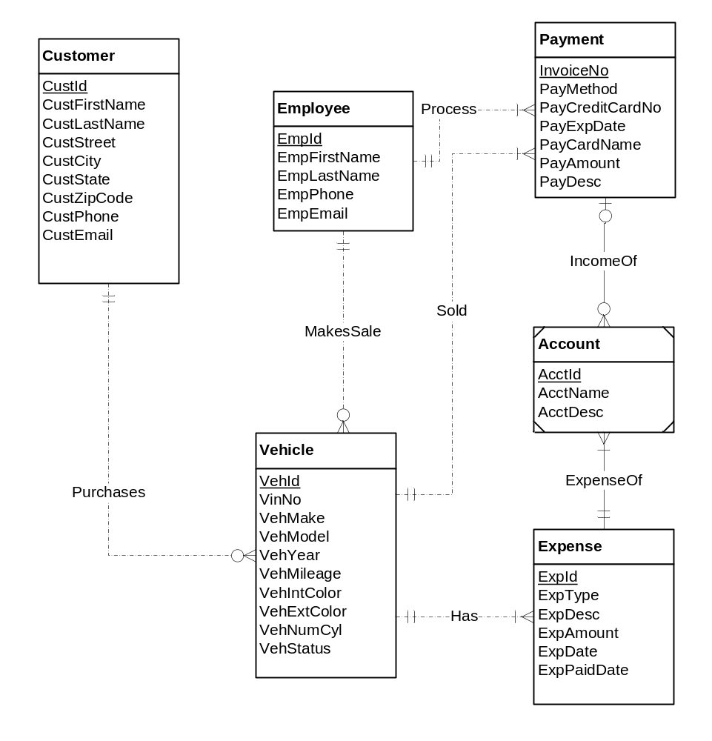
Figure 1: ERD for the Auto Dealership Database

Errors
Consistency Error : The cardinality of the 'IncomeOf' relationship near 'Payment' should be (1, 1).
Design Errors :
- A account can make multiple payments.
- A payment can be made from only one account
- An Expense can be made from only one account
- A Account can pay for multiple Expenses
- Not every vehcile have expenses so minimum cardinality can be 0
- Employee can have no Vechile for sale hence minimum cardinality for employee payment can be 0.
- Account can be made Strong Entity with AcctId as primary Key
- IncomeOf and ExpenseOf Relationship can be regular(non - Identifying).

